City of ________________
DEPARTMENT OF PUBLIC SERVICE
ENGINEERING DIVISION

Your City Logo Here

Steel Plates Requirements Used in
Connection with Roadway
Utility Excavations

MONTH – 2021

Table of Contents

1. PURPOSE 2
2. OBJECTIVE 2
3. BACKGROUND 2
4. PERMIT APPLICATION AND NON-CONFORMANCE 3
4.1. Permitting 3
4.2. Non-Conformance 3
5. USE OF STEEL PLATES IN THE TRAVELED WAY 3
5.1. Steel Plates Requirements 3
Figure 1 – PUPS Identification Colors 4
5.2. Steel Plates Details 5
Figure 2 - Steel Plate Detail 5
5.3 Installation 6
5.3.1 Type 1 Installation 7
Figure 3 – Type 1 Installation Detail 7
5.3.2 Type 2 Installation 8
Figure 4 – Type 2 Installation Detail 8
6. SAFETY 9
6.1 Signage 9
6.2 Seasonal Requirements 9
Figure 5 - Steel Plate Ahead Sign Detail 10
7. UTILITY CUT RESTORATION 10
7.1 Excavation/Backfill 11
7.2 Pavement Restoration 11
Figure 6 – Utility Cut Restoration Detail 12

1. PURPOSE
The purpose of this document is to establish and promote uniform policies for the placement, identification and removal of steel plates over open excavations within the public right-of-way in the City of __________.

2. OBJECTIVE
These requirements are intended to provide a high level of service of City streets by ensuring that the streets are left in the same condition in which they were found before the excavation, and establishing criteria for the use of steel plates during the cutting of pavement, excavating, backfilling and repairing of pavements cuts. This will reduce congestion and hazards along with increasing public service and safety in and out of construction sites.

3. BACKGROUND
Steel plates are used primarily in urban areas where an excavation is made in the roadway for utility work, such as installing or replacing utility lines, pipes and conduits. Steel plates are positioned on the roadway to cover the excavation and allow traffic to proceed when utility work is not underway. Motorcyclists and bicyclists are challenged when they traverse an unexpected plate.
The use of steel plates by utility companies and their contractors in the City of __________ as a temporary cover over an excavated area in a vehicular travel lane can present safety hazards and other problems if allowed to remain in place for extended periods and not properly secured. Some of the problems include:
- Plates being installed incorrectly resulting in the loud rattling of the plates.
- Plates not clearly marked in a location easily visible with no way of determining the owner of the plate.
- Plates being used as a permanent roadway fix.
The City of __________ grants permission for placement of all proposed utilities and for all construction and maintenance work in public rights-of-ways and easements by issuing a permit from the Engineering Division.

4. PERMIT APPLICATION AND NON-CONFORMANCE
4.1. Permitting
Any work in the street, alley, or right-of-way requires an engineering permit from the Engineering Division. This permit allows the utility company or a contractor hired by the utility company or an individual to conduct the work within the right-of-way. Approval of the Engineering Division is required prior to the starting the work. Construction drawings and a site specific traffic control plan issued by the City’s Traffic and Transportation Department must be submitted with the permit application form.
4.2. Non-Conformance
Failure to comply with applicable permitting requirements would be considered a violation of City Ordinances and lead to non-conformance fines as outlined below.
$1,000 for failing to cover a street cut
$400 for displaced plates
$400 for non-skid resistant surface
$400 for improper ramping
$250 for failure to mark perimeter of plates
$250 for failing to post signage

5. USE OF STEEL PLATES IN THE TRAVELED WAY
When backfill operations of an excavation in the traveled way, whether transverse or longitudinal, cannot be properly completed within a work day, steel plate bridging manufactured with a non-skid surface with a nominal Coefficient of Friction (COF) of 0.35 as specified by ANSI, ASTM, NEPA and OSHA, will be required to preserve unobstructed traffic flow in City streets and roadways. In such instances the following applies:
5.1. Steel Plates Requirements
- Steel plates must be able to withstand HS-20-44 traffic loading without any movement.
- Steel plates shall be fabricated to meet ASTM A36 steel requirements.
- When two or more of plates are in place more than three consecutive days without the need to accomplish work or inspections, the plates shall be tack welded together at each corner to reduce or eliminate vertical movement. Other alternative methods to accomplish this will be considered for approval.
- Steel plates shall be installed to resist bending, vibrations, etc., under traffic loads and when installed using a type 2 installation; shall be securely anchored with standard railroad spikes or other round smooth headed pins pre-drilled into the corners of the plate, and driven into the pavement section a minimum of 6”. If these conditions are not met, the applicant will be required to backfill and pave the excavation daily.
- All steel plates within the right of way whether used in or out of the traveled way shall be without deformation. Inspectors can determine the trueness of steel plates by using a straight edge and should reject any plate that is permanently deformed.
- All steel plates shall be properly marked with the utility and contractor name, including a SC-PUPS identification color marking shown in Figures 1 and 2, using the method and materials of their choice. Identification markings must be permanent in nature.

UTILITY/ TYPE OF PRODUCT | IDENTIFICATION COLOR
GAS, OIL, STEAM, PETROLEUM | YELLOW
ELECTRIC | RED
POTABLE WATER | BLUE
COMMUNICATIONS, TV | ORANGE
SEWER AND DRAIN LINES | GREEN
RECLAIMED WATER, IRRIGATION | PURPLE
TEMPORARY SURVEY | PINK

Figure 1 – PUPS Identification Colors
- It is the responsibility of the permitee to perform and document daily inspections of all active plate(s) or unattended plate(s) location(s), and where necessary take appropriate measures to protect the public safety until work is completed. This documentation shall be available to the City inspector upon request. No un-plated excavation shall be left unattended overnight.
- In the event of improper installation of the steel plates that presents a nuisance or a public safety problem, the permitee shall respond to all excavation restoration requests by the City immediately upon notification. Non-responses will result in the required restoration work be done by the City, with all expenses to be paid by the permitee.
- Steel plates must extend a minimum of 12-inches beyond the edges of the excavation.
- Before steel plates are installed, the excavation shall be adequately shored to support the bridging and traffic loads.
- Temporary paving or cold-mix asphalt concrete (cutback) shall not be allowed to secure or to prevent movement of trench plates unless prior approval is given by the engineer. Other alternative methods to accomplish this will be considered for approval.
- When plates are removed, all anchor/pin holes in the pavement shall be backfilled with an asphalt mix to the satisfaction of the City Inspector.

5.2. Steel Plates Details
Typical drill holes pattern and identification markers affixed to the top of plate, details are shown below.
Variable width, minimum 48”

24“ Typical
3“ Typical
2.5“ Typical

Variable length, minimum 60”

Drilled holes to accommodate common railroad spikes, or other round smooth headed pins when a type 2 installation is required

Utility Name & PUPS
Identification Color
Markings

Utility Name & PUPS
Identification Color
Markings

Figure 2 - Steel Plate Detail

5.3 Installation
For trenches and excavations with spans greater than four feet (4'), a structural design shall be prepared by a registered civil engineer and approved by the City. Steel plate placement on traverse and longitudinal excavations shall be in accordance with the following:

Steel Plate Installation | Street/Road Type |  | Posted Speed Limit
TYPE 1 | Urban/Residential |  | 45 MPH or Less
TYPE 2 | Arterial/Collector |  | Greater than 45 MPH
HS-20-44 Loading
Plate Thickness (Inches) |  | Maximum Allowable Span (Feet)
1” |  | 4’ 0”
1 ¼” |  | 7’ 0”
1 ½” |  | 10’ 0”

5.3.1 Type 1 Installation
Type 1 installation shown in Figure 3, shall be used in areas where backfilling operations of an excavation in the traveled way, whether traverse or longitudinal cannot be properly completed within the same day, and the posted speed limit is 45 MPH or less. Steel plates shall be securely anchored around the entire perimeter with the Plate Locks™ road plate securing system or approved equal, per manufacturer’s recommendation. Temporary paving or cold-mix asphalt concrete (cutback) shall not be allowed to secure or to prevent movement of trench plates unless prior approval is given by the engineer. Wedges or other non-asphaltic devices shall be used for leveling as required to eliminate rocking of the plates.

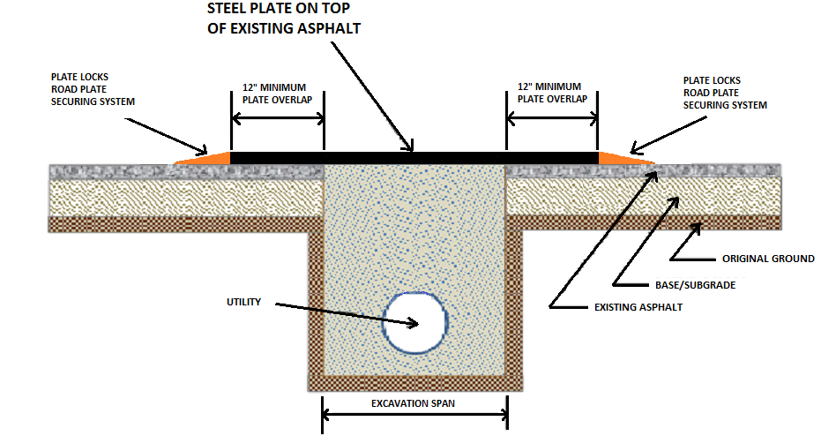
Figure 3 – Type 1 Installation Detail

5.3.2 Type 2 Installation
Type 2 installation shown in Figure 4, shall be used in areas where backfilling operations of an excavation in the traveled way, whether traverse or longitudinal cannot be properly completed within the same day and the posted speed limit is greater than 45 MPH. The steel plate for type 2 installations shall be recessed by milling into the existing asphalt to set flush with the surface of the existing asphalt. The pavement shall be cut and cold planed to a depth equal to the thickness of the plate and to a width and length equal to the dimensions of the plate. Full depth cutting of the asphalt section of excavation is not allowed. The steel plate shall be securely anchored with standard railroad spikes or other round smooth headed pins. Compacted temporary asphalt (cold mix) shall be used to fill the gap between the edge of the plate and the adjacent existing asphalt pavement. Wedges or other non-asphaltic devices shall be used for leveling as required to eliminate rocking of the plates.
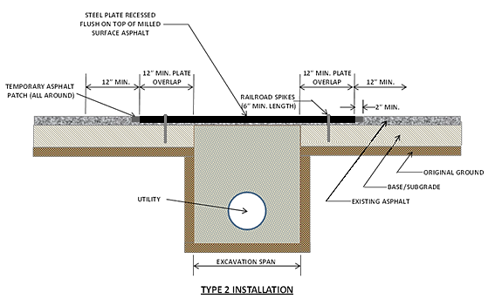

Figure 4 – Type 2 Installation Detail

6. SAFETY
Provisions should be made for the safety and protection of vehicular and pedestrian traffic during the construction period as follows:

- The permitee shall be responsible for the furnishing, erection and maintenance of all required traffic control devices. All signs and devices shall conform to the requirements of the current edition of the Manual on Uniform Traffic Control Devices (MUTCD).
- When in the opinion of the City Inspector, the work constitutes a hazard to traffic in any area of the work, the permitee may be required to suspend operations during certain hours and to remove any equipment from the area of work
- The roadway surface shall be kept clean of debris at all times and should be thoroughly cleaned at the completion of the work.
- The permitee shall be responsible to replace all pavement markings in kind which have been disturbed as a result of the utility work

6.1 Signage
In addition of the traffic control devices required by the Engineering Division Permit, warning signs advising motorist that they should expect to encounter steel plates, shall be placed at approximately 100 feet in advance of the steel plate location. The W8-24 warning sign, “STEEL PLATES AHEAD” meeting the requirements of the MUTCD, is shown in Figure 5 below. Plates left overnight may require, at the discretion of the Engineering Division Inspector, that the sign be supplemented with a Type “A” Low-Intensity-flashing warning light mounted on the sign support.
6.2 Seasonal Requirements
When approved for use, between November 15 and April 15 steel plate corner limits shall be marked with a 2 inch square stake painted International Orange and extending at least 4 feet above the ground, placed adjacent to the plated edge of the roadway in consideration of snow plows.
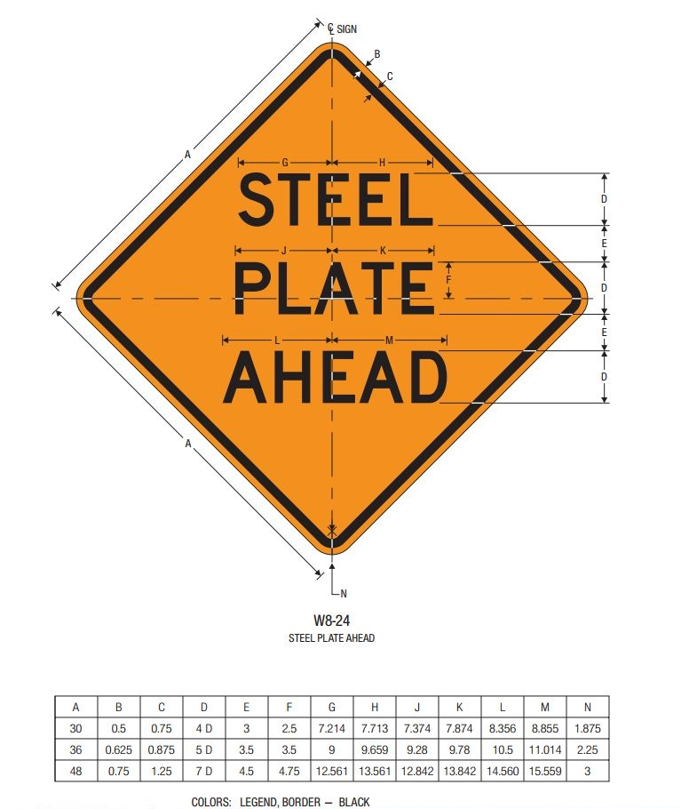
Figure 5 - Steel Plate Ahead Sign Detail

7. UTILITY CUT RESTORATION
Pavement settlement occurring in and around utility cuts in the City is a common problem, resulting in uneven pavement surfaces, annoyance to drivers, and ultimately, further maintenance by the City. Factors influencing the performance of a patch include:
- Pavement material, soil conditions, climate, traffic and repair techniques.
- Poor construction techniques which damage the area adjacent to the cut and further degrade the patch and surrounding pavement.
- Pavement cut repairs made using quality materials and sound engineering and construction techniques tend to perform as well as the surrounding pavement.
- Poor performance of the patch tends to be a result of inadequate compaction of the materials, insufficient thickness of materials, poor quality of materials, and damage to the side of the cut.

7.1 Excavation/Backfill
- Prior to proceeding with the utility cut repair, the Engineering Division shall be notified by the permit applicant to approve the repair limits and agree on the repair procedures
- The surface of the roadway to be excavated for the utility work shall be saw-cut in reasonably straight and parallel lines. The cutting excavation should not be done with a backhoe, gradeall or any other type of ripping equipment.
- Existing pavements, bases, curbs/gutters and sidewalks shall be cut and brought to a neat line. Expansion joints removed shall be replaced. The cutting and replacement of concrete curbs/gutters and sidewalks shall be from joint to joint and of complete panels.
- Backfill material shall meet the applicable requirements of the current edition of the Standard Specifications for Highway Construction for backfill material. Unsuitable material will not be allowed for backfill.

7.2 Pavement Restoration
The permitee shall be responsible to replace all pavement disturbed with a homogeneous and in-kind asphalt mix, and the details shown in Figure 5.

- All existing pavement surface should be swept clean of dirt, dust and debris prior of patching
- The existing vertical pavement shall be tack coated with an appropriate asphalt tacking material prior to patching
- When the pavement remaining between the excavation and the edge of the roadway is less than to 2 feet, the remaining area shall be removed in conjunction with the permanent repair.
- Placement of granular stone base or flowable fill shall not be performed until the excavation is inspected and approved by the Engineering Division inspection team.
- At the completion of the installation of the granular stone or flowable fill, the Engineering Division shall be requested to inspect the backfill. After acceptance of the backfill, the asphalt pavement can be applied.
- The work performed shall be free from workmanship defects for a period of one (1) year after date of acceptance by the Engineering Division.
- If permanent pavement restoration cannot be completed within three (3) days, then temporary patch of 2-inches of cold asphalt mix over compacted granular stone will be allowed. Permanent pavement repair to be completed within the time period required by the inspector.
- Any disturbed pavement markings must be restored to match adjacent striping.
- Crack seal around asphalt patch may be required at the discretion of the Inspector when there is a gap present.
- Spoil piles must be removed and the area must be cleaned and restored to like or better condition.
- Traffic control devices removed.

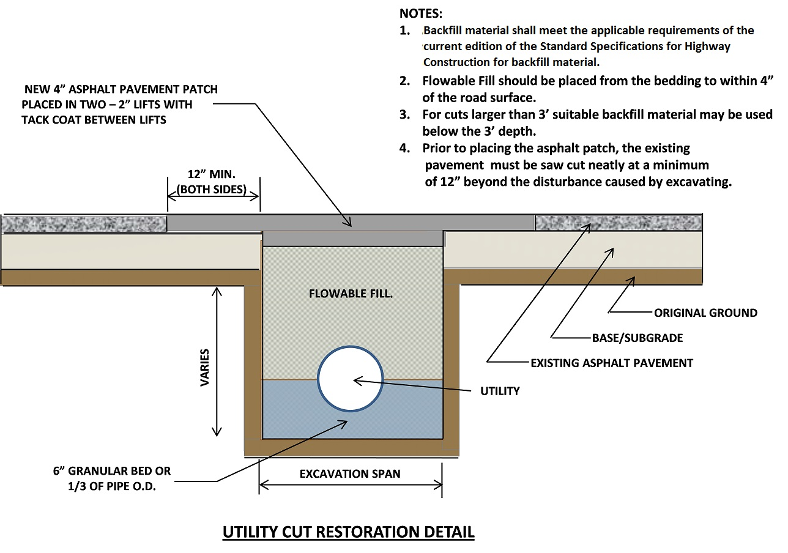

Figure 6 – Utility Cut Restoration Detail

